

[www.cariadproperty.com](http://www.cariadproperty.com)

01495 442315

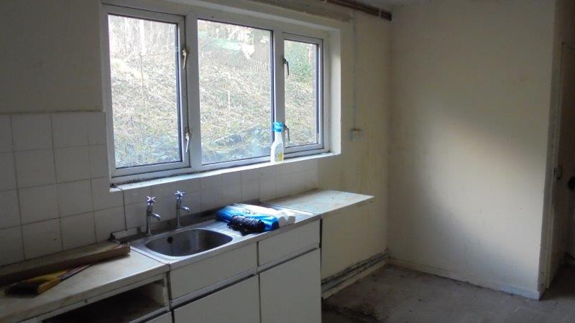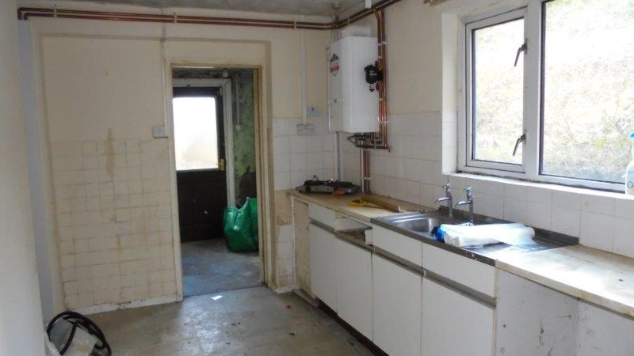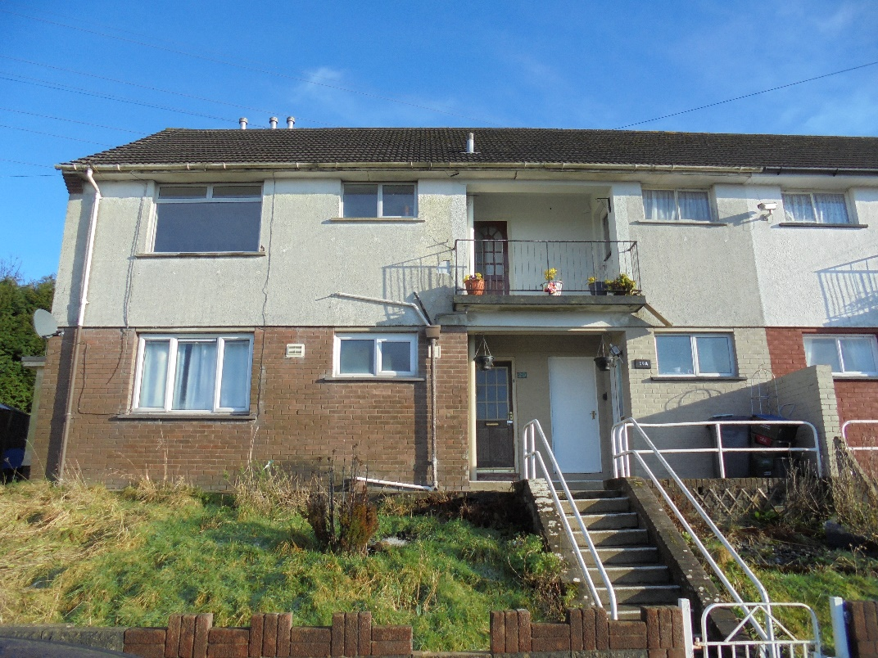

**£39,500**

**Early viewing**

**Essential.**

**29 HECTOR AVENUE**

**SWFFRYD**

**2 BEDROOM GROUND FLOOR FLAT.**

* Excellent buy to let

or first time buy.

* Large gardens front and rear.
* Two double bedrooms.
* Spacious lounge.
* Spacious kitchen/diner.
* Additional side access room with extra storage.
* UPVC double glazing.
* NO CHAIN

**ONLY £49,950**